LANCELOT
OR HOW TO BE A KNIGHT

PRODUCED BY THEATRE EN ANGLAIS

WORKSHEET : KNIGHTS

Vous trouverez également ces exercices autour de la thématique du chevalier parmi ceux des « SCENE BY SCENE WORKSHEETS », mais le cas où vous n’avez pas le temps d’aborder toutes les scènes, on vous les présente ici de manière plus simple.

Useful vocabulary – vocabulaire utile

Armour – l’armure
Battle-axe – la masse d’armes
Castle – le château (fort)
Challenge – le défi
Coat of arms – les armes
Coat of mail – le haubert
Curse – le mauvais sort
Dragon – le dragon
Dwarf – le nain
Feat (of arms) – l’exploit, le fait d’armes
Forest – la forêt (enchanted forest – la forêt enchantée
Giant – le géant
Helmet – le heaume
Herald – le héraut
Horse – le cheval
Joust – la joute
Jousting – l’activité de jouter
Knight – le chevalier
Lady – La Dame
Lance – la lance
Magician – le magicien
Palfrey – le palefroi
Quest – la quête
Shield – l’écu
Spear – la lance, l’épieu
Squire – l’écuyer
Sword – l’épée
To joust - jouter
Tournament – le tournoi

TRUE OR FALSE :

- A dwarf is a very tall person.

- A dragon breathes fire.

- A helmet protects a knight’s head.

- A palfrey is a type of dog.

- A squire is learning to be a knight.

- Knights never live in castles.

- In battle, a knight always wears a shield on his head.

- A knight fights with his Lady.

- Giants are very tall people.

- There are many trees in a forest.

Answers:
- False. A dwarf is a very short person
- True.
- True.
- False. A palefry is a type of horse, used for travelling, not jousting or fighting.
- True.
- False. Knights sometimes live in castles.
- False. In Battle, a knight wears a helmet on his head.
- False. A knight fights for his Lady.
- True.
- True.

Cherchez dans la grille ci-après les dangers et les obstacles qu’un chevalier peut rencontrer sur son chemin !

T | O | U | R | N | A | M | E | N | T
V | N | M | T | D | W | A | R | F | O
A | F | A | L | R | B | G | K | J | M
B | M | G | B | A | I | U | C | E | P
Z | H | I | A | G | O | T | A | E | A
V | L | C | F | O | R | E | S | T | S
L | G | I | A | N | T | N | T | R | L
C | S | A | B | C | H | D | L | W | K
R | M | N | F | R | Q | S | E | B | U
E | B | J | L | H | Y | D | A | L | Z

(La liste des mots cachés : dwarf, dragon, forest, castle, lake, giant, magician, lady, tournament.)

LE CHEVALIER

Remplissez les blancs à partir des mots suivants:

Lance, Banner, Visor, Helmet, Armour, Shield, Horse

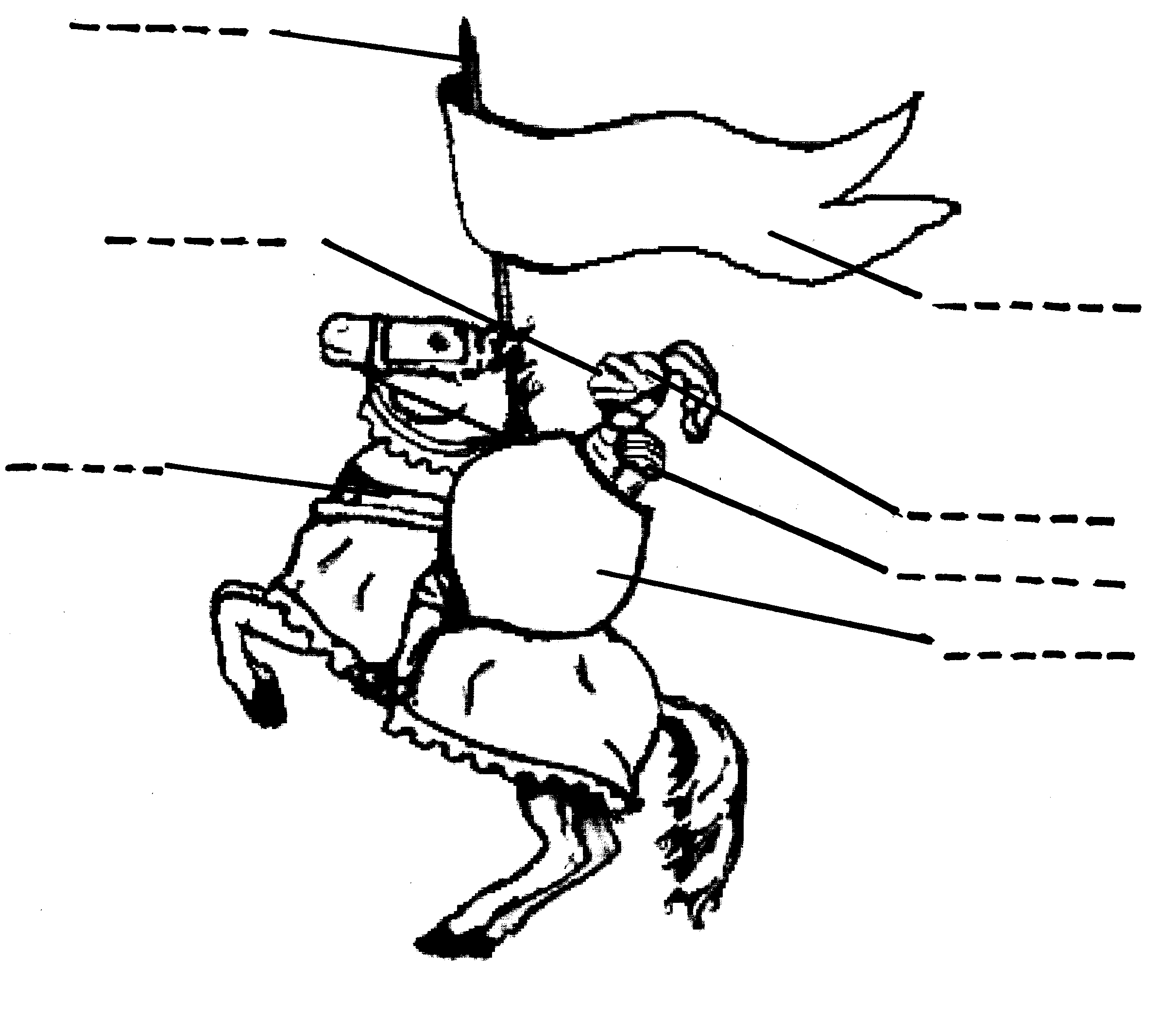
Cette image a été téléchargée du site suivant : http://historymedren.about.com/library/weekly/aa061898.htm

The rules of Knighthood

A knight is always brave.
A knight is honourable and never retreats before his enemies.
A knight never lies and always keeps his promise.
A knight is always courteous and polite.
A knight protects and defends the weak.
A knight is generous.
A knight fights for good against evil.

Discussion : suggérez comment suivre ces règles aujourd’hui…

http://theatre.anglais.free.fr

mail : theatre.anglais@wanadoo.fr

Tel + fax : 01 55 02 37 87

